2-1 Journal: Explore Conditional Statements in Programming

Real-world scenario: the purchase of stock
A real-world scenario that would involve the use of conditional statements is the purchasing of stock through a brokerage account. For this example, the user would be given the option to purchase stock from three different companies: Disney, Netflix, and Comcast. The program would need to obtain data related to prices of the stock involved and the user’s account balance to determine whether the available investment options are within the constraints of the user’s ability to pay given their account balance.

The structure of the decision-making process: The structure of the decision-making process, as outlined in Figure One, is as follows once the user has decided to make an investment purchase the user will be prompted to select the type of stock that they are interested in purchasing. Next, the program would need to receive input from the user about the amount of money they are interested in investing, which should be limited to be less than or equal to the account balance (in the case of this example $457.23). The program uses the investment budget as input to run a calculation of the maximum number of shares the user could purchase given their investment budget. The user then sees this output and can enter a stock share number that is equal to or less than the calculated maximum. Finally, the program confirms that the user wants to make the transaction and if so, the transaction is processed.

The conditions that would need to be evaluated: There are several conditions that need to be evaluated, most importantly whether the cost of the stock desired to be purchased can be paid for with the user’s current account balance, see Figure Two. This necessitates that controls are in place so that the user doesn’t inadvertently attempt to purchase more stock than their current account balance will allow. For example, the investment budget input is checked to ensure that it is not greater than the account balance or else the next portion of the code that calculates the number of shares that can be purchased is not executed. Additionally, when the user manually enters the number of shares they want to purchase, a control is in place to ensure that this is not greater than the calculated maximum number of shares, if it is the user cannot go further in the process.

The potential limitations of the solution: The example of purchasing stock is limited in that the user can only look at one stock at a time instead of coming up with an investment purchase that encompasses multiple stocks. This would require more complicated calculations and more input from the user regarding their stock preference and acceptable level of investment risk.

Explain the implications of poorly designed conditional statements. Consider the following:
Code readability: If conditional statements are poorly designed it can be difficult to follow the logic of the program. This can lead to decreased efficiency and difficulty correcting errors in the code. White space, descriptions, and flowcharts can help to mitigate this.
Maintenance: If conditional statements are poorly designed and contain nested statements this increases the likelihood of a change being made in one section inadvertently impacting other sections of the code.
Performance: If conditional statements are poorly designed in that the conditions that should be checked first are not executed prior to running calculations or initiating transactions this can lead to a decrease in efficiency and longer running times.
Testing complexity: If conditional statements are poorly designed the code’s inefficiency can result in an increased amount of time needed to check the code since each if statement creates a new branch that needs to be followed through for testing.
Explain how you would implement the solution using Python code, including the logic behind if, elif, and else statements:
The primary decision in the example code (see Figure Two) is the choice of investment leading to an elif statement based on the stock selected. Within each nested elif function there are if and else statements to ensure that the requested stock shares do not exceed the calculated maximum number of shares and that the user has confirmed the purchase before it is executed.
Discuss the advantages of using conditionals for the chosen scenario:
The main advantages of the conditionals developed are that they prevent the user from making a stock purchase that would make their account balance go below zero and controls are in place so that the user must verify the transaction information prior to it being executed.
Discuss any challenges that could be encountered when applying these structures:
In the real world it would not be possible for the account balance or the stock prices to be defined as easily. The user’s account balance would be subject to change due to other stock transactions, the receipts of dividends and interest, and the payment of investment management fees. This would necessitate the importing of the current account information prior to beginning to run the program. The same impact would also be seen on the stock prices which would change as their values on the market change and would need to be updated to reflect their current market value at the time of the program being run.

Figure One: Stock Purchase Flowchart
Account owner opens stock purchasing interface

Would the user like to begin to purchase a stock?

No
Which stocks would you like to investigate purchasing? Disney, Netflix, or Comcast
Yes
Would the user like their current account balance?

Yes
No

Stop
Account balance is given
Amount that you would like to invest

Stop

Calculation of the maximum amount of stock that could be purchased

User confirms shares and transaction

The same process is executed regardless of the stock type (Disney, Netflix, or Comcast)

The transaction is executed

Stop
Figure Two: Python Code Example
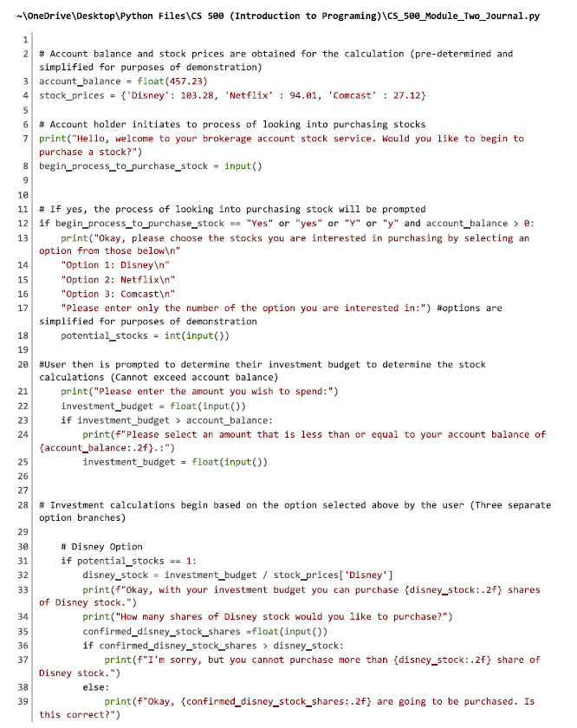

Figure Two: Python Code Example (Continued)
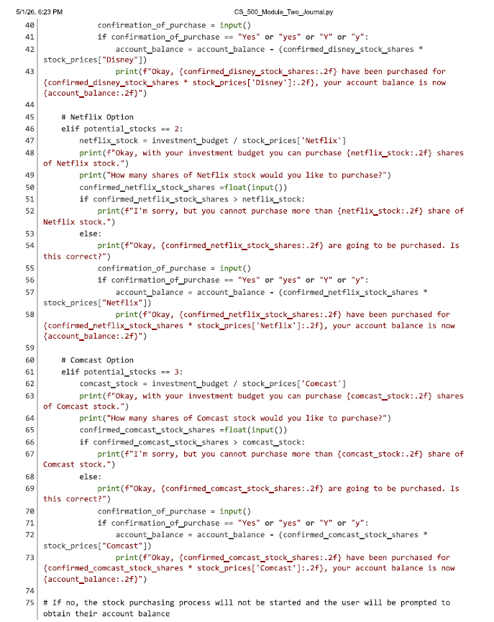

Figure Two: Python Code Example (Concluded)
